

Rhythmic Gymnastics Manitoba
Interclub Program
Technical Manual 2024
Introduction: The Rhythmic Gymnastics Manitoba Interclub Program
The Interclub program is a pre-competitive Rhythmic Gymnastics program for gymnasts who are seven years and older. Rhythmic Gymnastics Manitoba, in collaboration with several clubs in the province, developed the Interclub program in response to the growing need for a level that fits between the recreational and competitive structure. The program follows the GymCan Long Term Athlete Development model, which focuses on the Fun, Fitness, and Fundamentals of Gymnastics. It provides gymnasts the opportunity to participate in competitions as individuals and/or as a small group, and to experience success and challenge at an appropriate level based on their age, goals, and level of commitment to the sport.
The Interclub program is modified each year to ensure its alignment with the CanGym Recreational Program and the GymCan Development Programs for the current competitive year. The program provides a smooth transition from the Recreational Stream, and the opportunity for gymnasts to find meaning and challenge in pursuing the Interclub level. The program also allows clubs, gymnasts, and coaches to develop skills that could be transferred into the Provincial Stream program should they choose to pursue that as an option in the future.
Athletes, coaches and judges in the Interclub program are not limited to involvement in Interclub activities and are encouraged to expand their sport experience and physical literacy through participation in other types of physical activity.
Main Objectives of the Interclub Program
- To offer a program that is fun, challenging, and rewarding for all participants
- To provide an introductory competition program that is welcoming to new clubs, gymnasts, and judges
- To facilitate a smooth transition between Recreational Stream and Provincial Stream for those who wish to progress to that level
- To emphasize participation over performance scores
- To reward athletes for their participation and personal development
Eligibility/Registration
Clubs are responsible for determining gymnasts’ eligibility for a training and competition program based on a number of factors such as age, personal goals, level of commitment, and abilities. As a general rule, registered gymnasts with Rhythmic Gymnastics Manitoba (RGM), who are seven years or older in the competitive year, are eligible to train and compete at the Interclub level.
Every club registers their athletes with RGM as part of their annual registration process. Registration with RGM is mandatory for gymnasts who train and compete at the Interclub level.

Coaching
Each participating club must have at least one coach who is trained in Gymnastics Foundations - Rhythmic. However, coaches are encouraged to pursue higher training in the NCCP.
Coaches are required to attend an RGM Interclub Coaching/Judging course, and are strongly encouraged to participate in RGM coaching workshops. Coaches should be familiar with the FIG Rhythmic Gymnastics Code of Points, as the Interclub Technical Rules are based on rules that govern our sport on an international scale.
Judging
- New judges are required to attend an RGM Interclub Coaching/Judging course and strongly encouraged to, at a minimum, audit the RGM Club/Provincial Level Judging Course.
- Returning judges should attend an RGM Interclub Coaching/Judging Course any time significant changes are made to the program.
- Judges are required to be at least 15 years of age in the competitive year.
- Judging honoraria is at the discretion of the competition technical director. Judges can also request from the technical director signed confirmation of volunteer hours to be used for high school credit or for other reasons.
- The head judge at an Interclub competition must have a minimum of Club Level judging certification in the current cycle.
- All judges must conduct themselves in a professional manner at all times and abide by a code of respect and fairness when adjudicating performances.

Training Recommendations
Athletes in this program should train 1 to 2 times a week for 1 to 3 hours per class but not more than 6 hours per week of training.
*Refer to the GymCan Long Term Athlete Development Model for more detailed recommendations.

Event Guidelines for Athletes and Coaches
- A script, listing the required elements in the order of performance, must accompany the registration for each event. There are no penalties for scripting errors.
- An appropriate gymnastic leotard/bodysuit must be worn for competition. All outfits should conform to the rules outlined in the FIG Code of Points.
- Individual gymnasts may compete one or two routines. If performing one routine, it must be the compulsory routine for that age group.
- Groups may be comprised of three to five gymnasts. The group must perform with one of the specified apparatus for their level.
- Groups will perform their routines twice during the competition and will be awarded their highest score.
- Gymnasts may participate in a group and individual routine at the same event.
- A coach may stand at the edge of the competition floor, but is not to enter the performing area during a routine.
- There is no deduction for a coach reminding a gymnast what skill is next.

Guidelines for Interclub Event Organizers
- Interclub athletes should be charged no more than $70.00 for competition fees by the host club/organization.
- When possible, rhythmic carpets should be provided for the competition and practice areas by the host club/organization.
- Competitions should have a minimum of 5 judges for the Interclub rotation.
- Judging honoraria is at the discretion of the competition technical director. Judges can also request from the technical director signed confirmation of volunteer hours to be used for high school credit or for other reasons.
- The host club/organization should provide judges with copies of the scripts and table of faults just prior to the start of the Interclub rotation.
- In order to create a welcoming environment for athletes, competition hosts are encouraged to provide and opportunity for Interclub athletes to meet the judging panel prior to the start of their rotation (e.g.: high fives, brief pep talk).
- There will be no timing of routines during the competition.
- No scores should be posted during or after the competition. Coaches should have access to their athletes’ scripts at the end of the competition.
- Awards should be presented to all Interclub athletes. Level 1 and Introductory Level group athletes should receive Participation awards, regardless of their score.

Tables: Level/Age Categories and Routine Requirements
For the 2024 season, the following levels and requirements apply:
INDIVIDUAL CATEGORIES:
Level, Age, and Routine Length | Apparatus Option 1 | Apparatus Option 2
Level 1  Ages 7-8  1:00-1:15 | Free  - 3-4 body difficulties (min 1 of each type)  - Pre-Acrobatic series (min 1, max 2)  - Dance series (min 1, max 3)  - Body wave (min 2, max 3) | Choice (not free)  - 3-4 body difficulties (min 1 of each type)  - Dance series (min 1, max 3)  - Body wave (min 2, max 3)  - Apparatus Difficulty (min 1, max 2)  - Large throw or risk (min/max 1)
Level 2  Ages 9-10  1:00-1:30 | Free  - 3-4 body difficulties (min 1 of each type)  - Pre-Acrobatic series (min 1, max 2)  - Dance series (min 1, max 3)  - Body wave (min 2, max 3) | Choice (not free)  - 3-4 body difficulties (min 1 of each type)  - Dance series (min 1, max 3)  - Body wave (min 2, max 3)  - Apparatus Difficulty (min 1, max 2)  - Large throw or risk (min/max 1)
Level 3  Ages 9, 10, 11  1:00-1:30 | Free  - 4-5 body difficulties (min 1 of each type)  - Pre-Acrobatic series (min 1, max 2)  - Dance series (min 1, max 3)  - Body wave (min 2, max 3) | Choice (not free)  - 4-5 body difficulties (min 1 of each type)  - Dance series (min 1, max 3)  - Body wave (min 2, max 3)  - Apparatus Difficulty (min 1, max 2)  - Large throw or risk (min/max 1)
Level 4  Ages 11, 12, 13  1:00-1:30 | Free  - 4-5 body difficulties (min 1 of each type)  - Pre-Acrobatic series (min 1, max 2)  - Dance series (min 1, max 3)  - Body wave (min 2, max 3) | Choice (not free)  - 4-5 body difficulties (min 1 of each type)  - Dance series (min 1, max 3)  - Body wave (min 2, max 3)  - Apparatus Difficulty (min 1, max 2)  - Large throw or risk (min/max 1)
Level 5  Ages 13, 14, 15  1:00-1:30 | Choice (not free)  - 5-6 body difficulties (min 1 of each type)  - Dance series (min 1, max 3)  - Body wave (min 2, max 3)  - Apparatus Difficulty (min 1, max 2)  - Large throw or risk (min/max 1) | Choice (not free)  - 5-6 body difficulties (min 1 of each type)  - Dance series (min 1, max 3)  - Body wave (min 2, max 3)  - Apparatus Difficulty (min 1, max 2)  - Large throw or risk (min/max 1)
Level 6  Ages 15 and up  1:00-1:30 | Choice (not free)  - 5-6 body difficulties (min 1 of each type)  - Dance series (min 1, max 3)  - Body wave (min 2, max 3)  - Apparatus Difficulty (min 1, max 2)  - Large throw or risk (min/max 1) | Choice (not free)  - 5-6 body difficulties (min 1 of each type)  - Dance series (min 1, max 3)  - Body wave (min 2, max 3)  - Apparatus Difficulty (min 1, max 2)  - Large throw or risk (min/max 1)
Open  Ages 18 and up  1:00-1:30 | Choice (not free)  - 5-6 body difficulties (min 1 of each type)  - Dance series (min 1, max 3)  - Body wave (min 2, max 3)  - Apparatus Difficulty (min 1, max 2)  - Large throw or risk (min/max 1) | Choice (not free)  - 5-6 body difficulties (min 1 of each type)  - Dance series (min 1, max 3)  - Body wave (min 2, max 3)  - Apparatus Difficulty (min 1, max 2)  - Large throw or risk (min/max 1)

GROUP CATEGORIES:
Level, Age, and Routine Length | Apparatus Option and Requirements
Introductory Level  Ages 7, 8, 9  1:15-1:45  Group of 3, 4, or 5 | Free  - 3 body difficulties (min 1 of each type)  - Dance series (min 1, max 3)  - Body wave (min/max 2)  - Min 4 formations  - Min 3 collaborations
Level 3  Ages 9, 10, 11  1:15-2:00  Group of 3, 4, or 5 | Choice  - 3-4 body difficulties (min 1 of each type)  - Dance series (min 1, max 3)  - Body wave (min/max 2)  - Apparatus difficulty (min/max 1)  - Large throw or risk (min/max 1)  - Min 4 formations  - Min 2 collaborations  - Min 2 exchanges
Level 4  Ages 11, 12, 13  1:45-2:30  Group of 3, 4, or 5 | Choice  - 4-5 body difficulties (min 1 of each type)  - Dance series (min 1, max 3)  - Body wave (min/max 2)  - Apparatus difficulty (min/max 1)  - Large throw or risk (min/max 1)  - Min 4 formations  - Min 2 collaborations  - Min 2 exchanges
Level 5  Ages 13, 14, 15  2:00-2:30  Group of 3, 4, or 5 | Choice  - 5-6 body difficulties (min 1 of each type)  - Dance series (min 1, max 3)  - Body wave (min/max 2)  - Apparatus difficulty (min/max 1)  - Large throw or risk (min/max 1)  - Min 4 formations  - Min 4 collaborations  - Min 3 exchanges
Level 6  Ages 15 & up  2:00-2:30  Group of 3, 4, or 5 | Choice  - 5-6 body difficulties (min 1 of each type)  - Dance series (min 1, max 3)  - Body wave (min/max 2)  - Apparatus difficulty (min/max 1)  - Large throw or risk (min/max 1)  - Min 4 formations  - Min 4 collaborations  - Min 3 exchanges

Although the apparatus is a choice for all levels, coaches and gymnasts are encouraged to choose apparatus that is suitable based on their age, level, and stage of development.
Coaches select their own music and choreograph their own routines for athletes. Each routine has a specified list of routine elements that must be performed (as shown above). The required elements may be performed in any order within the routine.
Body Difficulties are to be selected from the following tables. These elements have been chosen from the FIG Rhythmic Gymnastics Code of Points. Body elements outside of this manual will not be credited.
JUMPS AND LEAPS:
NAME | SYMBOL | IMAGE | VALUE
Tuck jump (180°) | 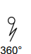 | 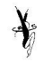 | 0.10
Cat leap turn (180°) |  | 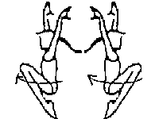 | 0.10
Vertical jump (360°) | 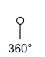 | 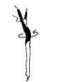 | 0.10
Passé jump (180°) |  | 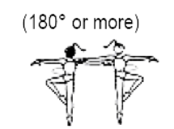 | 0.10
Cabriole |  | 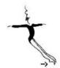 | 0.10
Scissor jump |  | 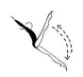 | 0.10
Cossack jump |  | 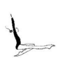 | 0.10
Stag jump (takeoff from 1 or 2 feet) | 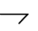 |  | 0.20
High scissor jump |  | 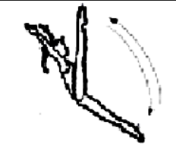 | 0.20
High cossack jump | 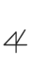 | 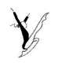 | 0.30
Double stag jump (takeoff from 1 or 2 feet) |  | 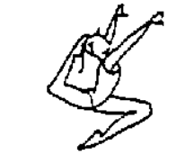 | 0.20
Switch stag leap |  | 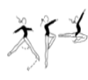 | 0.20
Fouetté leap |  | 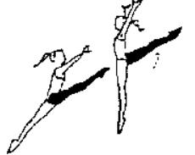 | 0.20
Fouetté stag leap |  | 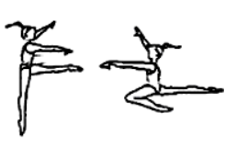 | 0.20
Split leap |  | 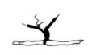 | 0.30
Entrelacé leap |  | 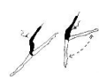 | 0.30
Straddle jump with high chest |    | 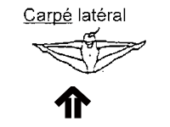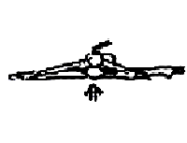 | 0.30
Turning stag leap | 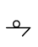 | 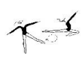 | 0.30

Note: Leaps should match the basic characteristics as listed in the FIG Rhythmic Gymnastics Code of Points.
There will be no downgrading of leaps and jumps by the judges (i.e.: changing double stag jump to stag jump based on what the athlete performs). Coaches should keep this in mind for their choreography and when submitting scripts for each competition.

BALANCES:
NAME | SYMBOL | IMAGE | VALUE
Passé |  |  | 0.10
Cossack |  |  | 0.10
Back attitude |  |  | 0.20
Front arabesque |  |  | 0.20
Back arabesque |  |  | 0.20
High Cossack |  |  | 0.20
Front assisted split |  |  | 0.30
Side assisted split |  |  | 0.30
Scale |  | 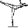 | 0.30
Back assisted ring |  |  | 0.30
Fouetté (leg at horizontal, minimum 2 shapes with 1 turn) |  |  | 0.30
Front split unassisted |  |  | 0.40
Side split unassisted |  |  | 0.40
Penché |  |  | 0.40

Note: Balances should match the basic characteristics as listed in the FIG Rhythmic Gymnastics Code of Points.
All balances should be visibly held for 3 seconds. All balances with values 0.20 or higher may be performed on flat foot. In that case, the balance should be scripted with a value of 0.10 lower than the above listed value.
The ⬇symbol should be included next to the balance symbol to indicate that the balance is to be performed on flat foot.
For example:
= 0.20
⬇ = 0.10
If a gymnast’s script states that they should perform a balance on relevé but it is performed on flat, the judge may downgrade the balance by 0.10. There will be no downgrading based on overall shape performed. The gymnast will be evaluated based on the balance listed on the script (e.g.: if script indicates front assisted split but performs front arabesque, the judge will evaluate the balance as 0.00). Coaches should keep this in mind for their choreography and when submitting scripts for each competition.

ROTATIONS:
NAME | SYMBOL | IMAGE | VALUE
Passé (360°) |  | 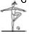 | 0.10
Bent over passé (360°) |  |  | 0.10
Fouetté (360°) |  | 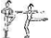 | 0.10
Cossack (360°) |  |  | 0.10
Illusion |  |  | 0.10
Split Roll (360°) |  |  | 0.10
Front arabesque (360°) |  |  | 0.20
Front attitude (360°) |  | 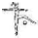 | 0.20
Back arabesque (360°) |  |  | 0.20
Back attitude (360°) |  |  | 0.20
Front assisted split (360°) |  |  | 0.30
Side assisted split (360°) |  |  | 0.30
Tonneau (360°) |  | 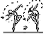 | 0.30
Scale (360°) |  | 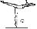 | 0.30

Note: Rotations should match the basic characteristics as listed in the FIG Rhythmic Gymnastics Code of Points. Rotations must be a minimum of 360° and will be evaluated only for the value listed in the table above (i.e.: no additional value for more rotation). All rotations must be performed on relevé, aside from the split roll and illusion.
There will be no downgrading of rotations by the judges (i.e.: changing the value of a rotation based on what the gymnast actually performs). Coaches should keep this in mind for their choreography and when submitting scripts for each competition.

Further guidelines:
- No elements or shapes should be repeated (e.g.: same balance, same Pre-Acrobatic element, etc.). Repeated elements or shapes will not be evaluated. Exception: Pre-Acrobatic elements with different levels of support are considered different (e.g.: cartwheel on hands is different than cartwheel on the elbows).
- Gymnasts may exceed the number of requirements (see Routine Requirements) for their age category, but should not include those skills on their scripts, as those extra skills will not be evaluated.
- All body elements are encouraged to be performed in combination with a form of apparatus handling.
- For apparatus routines, it is encouraged for athletes to perform Fundamental Apparatus Technical Groups as per the FIG Rhythmic Gymnastics Code of Points. There are no deductions in regards to this rule.
- Gymnasts should demonstrate a balance of the use of the left and right hand throughout the routine. There are no deductions in regards to this rule.
- For DA “on the floor” criteria will not be required for levels 1-3. DA on seat or on knees will count. On the floor criteria will be required for levels 4, 5, 6.
Technical Definitions
Large Throw: A large throw of the apparatus, required in routines where risks are not attempted. No rotation of the body is required, but the gymnast must be in motion, i.e. Performing a pose, balance, jump/leap, dance steps, etc, which may also be scripted if desired. May only be performed once.
Value: 0.1

Body Wave: A stationary element where the body contracts and extends in a sequential pattern. Gymnast must use all body segments possible (ie no single arm waves). Can be done forwards, backwards, sideways, or on the floor (ie worm or on the knees)
Value: 0.1

Risk (Dynamic Element of Rotation): A large throw of the apparatus with the rotation of the body around any axis during the throw or flight of the apparatus. Minimum one rotation is required.

Base Value: 0.2 (0.1 for throw + 0.1 for one rotation)

Each additional rotation of the body will add an additional 0.1 value. One rotation of the body may be performed during the “catch” of the apparatus and still be included as part of the risk. A change in axis or level may be claimed once for an additional 0.1 value.

Apparatus Difficulty: When performing with an apparatus, a demonstration of at least one Fundamental/Other Apparatus Technique in combination with at least one Apparatus Difficulty Criteria. Choose only from one of the following bases: Fundamental Apparatus Manipulations, Small Throws/Catches, Medium/Large Throws, Medium/Large Catches.
Value: 0.2

Fundamental Apparatus Manipulations:
Rope:
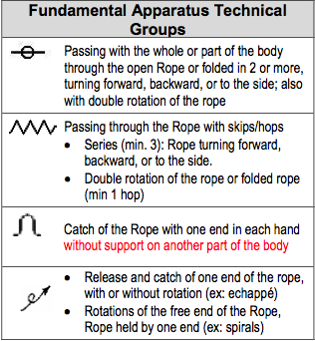
Hoop:
Ball:
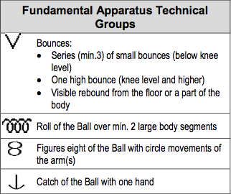
Clubs:
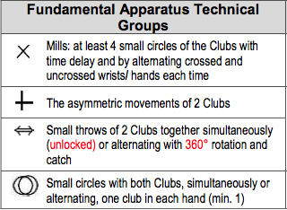
Ribbon:
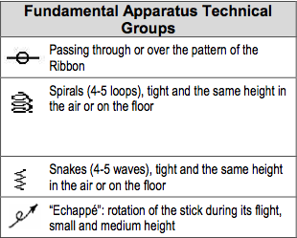

Dance Steps Combination: A minimum of 8 seconds of continuous connected dance steps (may be from ballroom, folklore, modern dance, etc.) showing different rhythmical patterns, combined with continuous apparatus movement (free routines must substitute with continuous arm movement).
Value: 0.3

Collaborations: In a group routine, an element that is performed which requires participation by all gymnasts (ie. A lift, an exchange, a group skill, etc). May be with or without throw/exchange of apparatus.

Value: 0.3

Pre-Acrobatic Series: For free hand routines only. Connected movements of rotational elements. May be the repetition of the same Pre-Acrobatic element (i.e. two cartwheels performed in a row), or may be a combination of varied skills (i.e. chaîné turn, cartwheel, bum roll). Maximum of 3 rotations/elements in a series.

Value: 0.2 for a series of 2 Pre-Acrobatic elements, and 0.30 for a series of 3 Pre-Acrobatic elements

Note: According to the GCG Technical Program, pre-acrobatic element series are only of value if the gymnast passes through the frontal axis (e.g.: cartwheel) or the transverse axis (e.g.: somersault). The Interclub Program allows gymnasts to pass through the longitudinal axis (e.g.: chaîné turn) for developmental purposes.

Exchange: Large throw of the apparatus to another gymnast.
Value: 0.3

Additional Symbols
Description | Symbol | Value
Pre-Acrobatic series | acro | 0.20 or 0.30
Dance step series | S | 0.30
Apparatus difficulty | DA  Note: on script, symbol is written in conjunction with symbol for Base Apparatus Manipulation, as well a brief written description of Apparatus Difficulty | 0.20
Large throw |  | 0.10
Body wave |  | 0.10
Risk with 1 rotation | R1 | 0.10
Risk with 2 rotations | R2 | 0.20
Change of level or change in axis in risk |  | 0.10 (apply one time to risk)
Group collaboration | C | 0.30
Group exchange | E | 0.30
Medium/Large Catch
Small Throw/Catch
Fundamental Apparatus Manipulation | See symbols in Technical Definitions Section

Scoring
The Difficulty Score is comprised of the technical difficulties in the routine. This includes:
- Body difficulties (balances, rotations, leaps/jumps)
- Pre-acrobatic series
- Dance steps combinations
- Body waves
- Apparatus difficulties
- Risks/DERs and/or large throws
Each body difficulty is worth the value listed in the table of elements (see notes after each table). Each apparatus difficulty and dance step series are worth the values assigned in the previous tables. DERs are calculated according to the technical definition in the previous section.
Gymnasts may exceed the number of requirements (see Routine Requirements) for their age category, however those extra skills will not be evaluated.
All body and apparatus difficulties to be evaluated should be listed on the script in the order in which they will be performed. For the benefit of the gymnast, judges will evaluate and award all skills listed on the script, regardless of the order they are performed.

Difficulty Score:
The Difficulty Score is comprised of the awarded value of each of the required elements listed on the script and performed in accordance with the basic characteristics for that element. If performed according to the requirements, difficulties are awarded the full assigned value (exception: balances performed on flat, which are downgraded by 0.10 if not already scripted to be on flat foot).

Execution Artistry Score:
The Execution Artistry Score is comprised of the artistic faults of the routine. Artistic faults are applied when, for example, the movement does not suit the music, the entire performance floor is not utilized, varied body and apparatus elements are not shown, or the choreography is disjointed. The Table of Artistic Faults is as follows:
Artistry Faults | Deduction
A defined character is present between or during the majority (but not all) of the connecting elements/movements and dance steps.  OR  A defined character or style is not fully developed in the dance steps; they are mainly walking, running or skipping to the accents without regard to the specific musical style. A defined character is present between or during some of the connecting elements and movements.  OR  There is no defined character of movement between the difficulties, which are presented as only a series of difficulties without a style of movement connected to the music. A defined character is only present during the Dance Steps Combination(s).  OR  The dance steps and connecting movements have no defined character. | 0.1 (one time)  OR  0.3 (one time)  OR  0.5 (one time)  OR  0.7 (one time)
Absence of logical and smooth transitions from one movement to the next | 0.1 each time (max 1.0)
Absence of harmony between movements and music | 0.1 each time (max 1.0)
Lack of variety in directions/travel | 0.2 (one time)
Entire floor area is not used | 0.2 (one time)
Lack of variety in levels and modalities of traveling | 0.2 (one time)
Lack of variety in planes, directions, and types of apparatus elements | 0.2 (one time)
Lack of contact with the apparatus at the beginning or end of the routine (composition fault) | 0.5 (one time)
Lack of body expression (segmentary, rigid movements in entire exercise) | 0.3 (one time)
Not ending with the music (gymnast either stops before music ends or continues after music has ended) | 0.5 (one time)

The Execution Technical Score is comprised of the technical faults of the routine. Technical faults are applied when body or apparatus difficulties are performed with faults, such as incorrect body or apparatus shapes, or drop of the apparatus. The Table of Technical Faults is as follows:
Body Faults | Deduction
Incomplete Movement | 0.1
Traveling without throw: adjusting body position on the floor | 0.1
Body segment held incorrectly (bent, fixed, etc) | 0.1 each time, up to 1.0
Loss of balance (Wobble) | 0.1
Heavy landing on a leap or Pre-Acrobatic element | 0.1
Shape of balance not held for a minimum of 1 second | 0.3
Heel down during a rotation element | 0.1
Axis of the body not straight during a pivot | 0.3
Hops during a rotation | 0.3
Static gymnast | Up to 0.9
Loss of balance with support of hand (s) or apparatus | 0.5
Total loss of balance with fall | 0.7
Apparatus Faults | Deduction
Imprecise trajectory of throw with 1 step | 0.1
Imprecise trajectory of throw with 2 steps | 0.3
Incorrect catch or help from another body part | 0.1
Incorrect shape, plane, or handling | 0.1 each time, up to 1.0
Feet caught in the rope, hoop, or ribbon | 0.3
Incorrect roll of the ball or hoop (bounces as it rolls) | 0.1
Lack of synchronization of club rotations | 0.1
Small knot in ribbon/rope (does not impair shape or handling) * | 0.1
Involuntary wrapping around the body with rope or ribbon | 0.5
Imprecise trajectory of throw with 2 or more steps | 0.5
Loss of the apparatus with no steps | 0.5
Loss of the apparatus with 1 or 2 steps | 0.7
Loss of the apparatus with 3 or more steps | 1.0
Loss of the apparatus at the end of the routine | 1.0

Total Difficulty Score: The average of each judge’s Difficulty scores equal the total Difficulty score. There is no maximum score, however there are limitations to the amount of skills claimed by each gymnast according to their levels.
Total Execution Score: The average of each judge’s Artistry faults and average of each judge’s Technical faults are combined and subtracted from 10.0 for the total Execution score. The maximum Execution score is 10.00.
The Total Score = Total Execution Score + Difficulty Score
There is no official Interclub scoring program. It is up to the host club of a competition to ensure all scoring is recorded correctly, efficiently, and submitted to Rhythmic Gymnastics Manitoba after competition.
Awards
The Interclub Program encourages a fun, rewarding, and positive participation experience. Each individual athlete should receive awards for each routine performed at competition.
No scores will be flashed during the competition to encourage a positive performance environment for all athletes. Scripts will be distributed to club coaches at the end of the competition, and scores must be submitted to Rhythmic Gymnastics Manitoba. Results should not be posted at the event, or on any media outlet.
Athlete awards should be presented in a random order to ensure that less emphasis is placed on ranking. No podium should be used when presenting athletes with certificates, medals, and ribbons. The announcer should announce the age group and then call up the athletes by name in random order and have them stand side by side. Use a similar fashion when presenting group awards.
Athletes in each age category will receive ribbons for their compulsory and optional routines. Gymnasts must achieve the following scores for each award:
Individual Routine Awards:
Level 1:
Athletes should receive Participation awards, regardless of their score.

Level 2 and 3:
Gold = Above 6.5, Silver = 5-6.5, Bronze = Under 5

Level 4 and 5:
Gold = Above 7, Silver = 5.5-7, Bronze = Under 5.5

Level 6 and Open:
Gold =Above 7.5, Silver = 6-7.5, Bronze = Under 6

Group All Around Awards:
Introductory Level:
Athletes should receive Participation awards, regardless of their score.

Level 3:
Gold = Above 6.5, Silver = 5-6.5, Bronze = Under 5

Level 4:
Gold = Above 7, Silver = 5.5-7, Bronze = Under 5.5

Level 5:
Gold =Above 7.5, Silver = 6-7.5, Bronze = Under 6

Level 6:
Gold =Above 7.5, Silver = 6-7.5, Bronze = Under 6

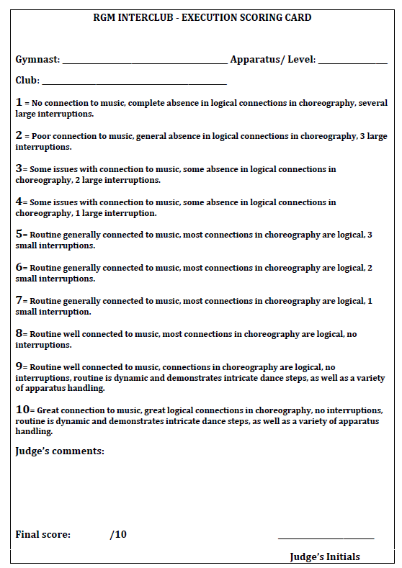

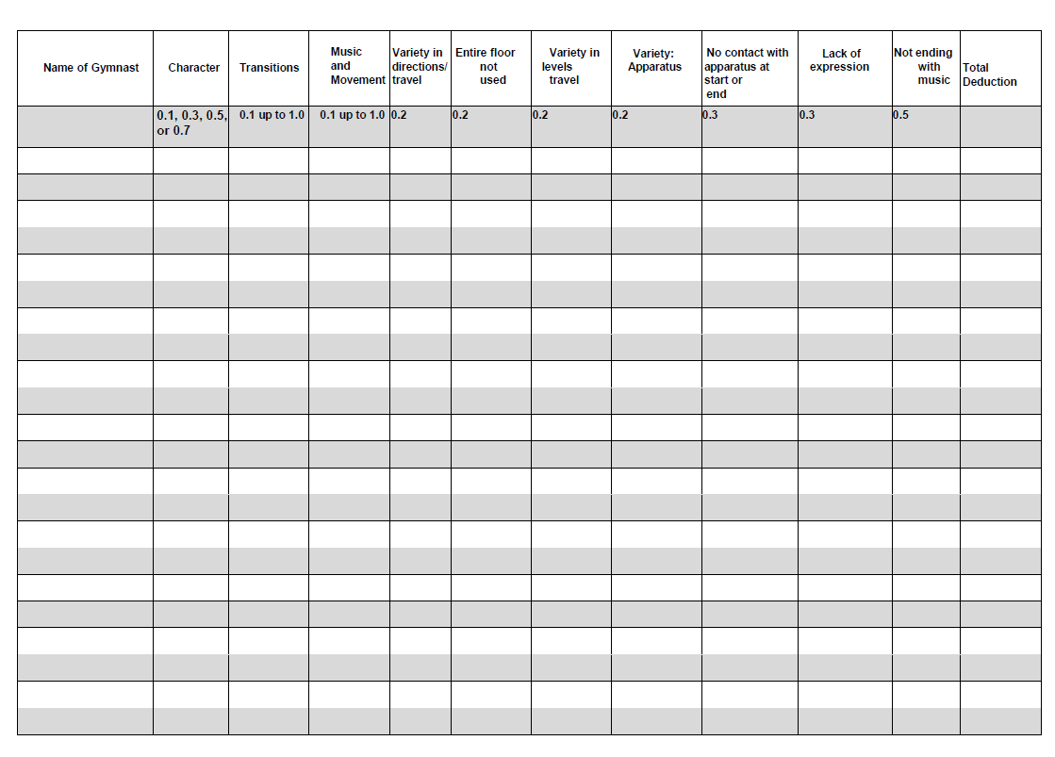

RGM Interclub Program
TECHNICAL EXECUTION
Gymnast/Group: ____________________________ Level/Apparatus: __________________
Club: ______________________________________
Execution Deductions:
Small Errors = 0.1 each time
- Incomplete movement
- Traveling without a throw
- Body segment held incorrectly
- Loss of balance (wobble)
- Heavy landing
- Heel drop in rotation (pivot)
- Incorrect catch (help with other hand or body)
- Incorrect shape, plane or handling of apparatus
- Knot (small, does not impair handling)
- Bouncing in a roll
- Lack of club synchronization
Medium Errors = 0.3 each time
- Axis of body not straight in pivots
- Hops in a rotation
- Shape of balance not held for a minimum of 3 seconds
- Static gymnast
- Imprecise trajectory with 1 step
- Feet caught in the apparatus
Large Errors = 0.5 each time
- Loss of balance with support of hand(s) or apparatus
- Involuntary wrapping around body (rope/ribbon)
- Imprecise trajectory with 2 or more steps
- Loss of apparatus (0 steps)
Major Errors = 0.7-1.0 each time
- Loss of balance with fall (0.7)
- Loss of apparatus with 1-2 or more steps (0.7)
- Loss of apparatus with 3 or more steps (1.0)
- Loss of apparatus at the end of routine (1.0)
TOTAL DEDUCTIONS:
JUDGE’S INITIALS:

